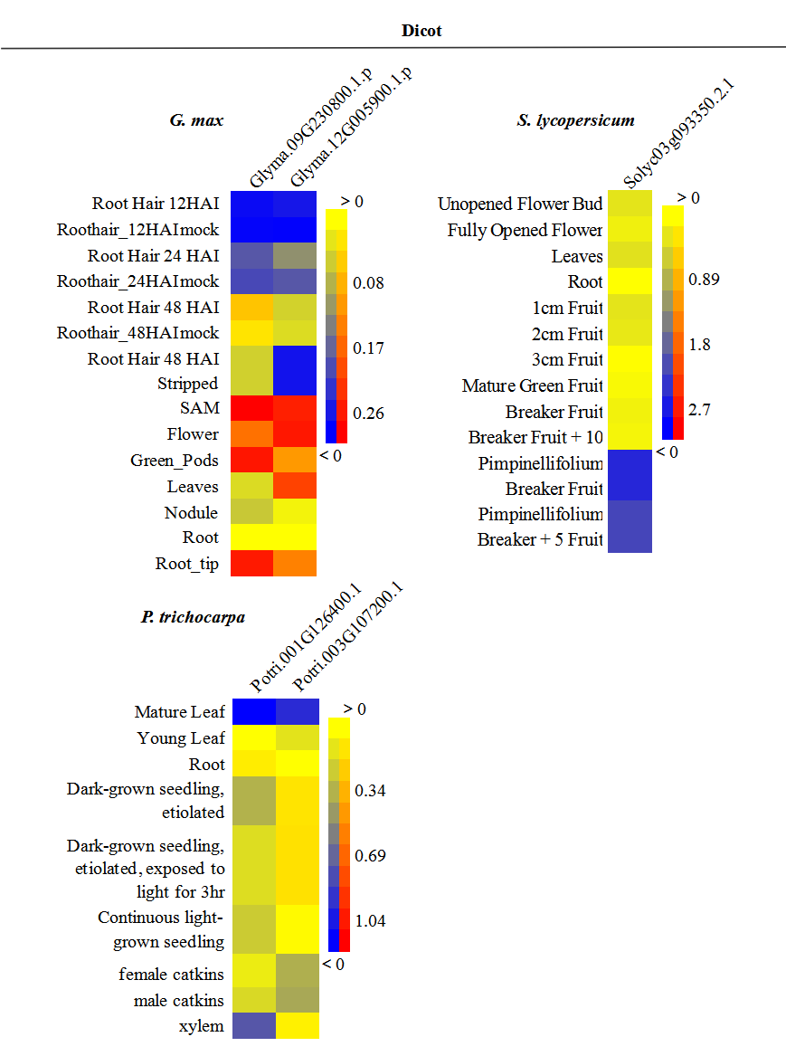
Figure S1 Expression patterns of Glycine max (soybean), Solanum lycopersicum (tomato) and Populus trichocarpa (poplar) SF1s. Expression data were obtained from plant eFP browser microarray datasets and transformed by Log₂ conversion and presented as heatmap. Red colour indicates high levels of transcript abundance and blue indicates low transcript abundance.

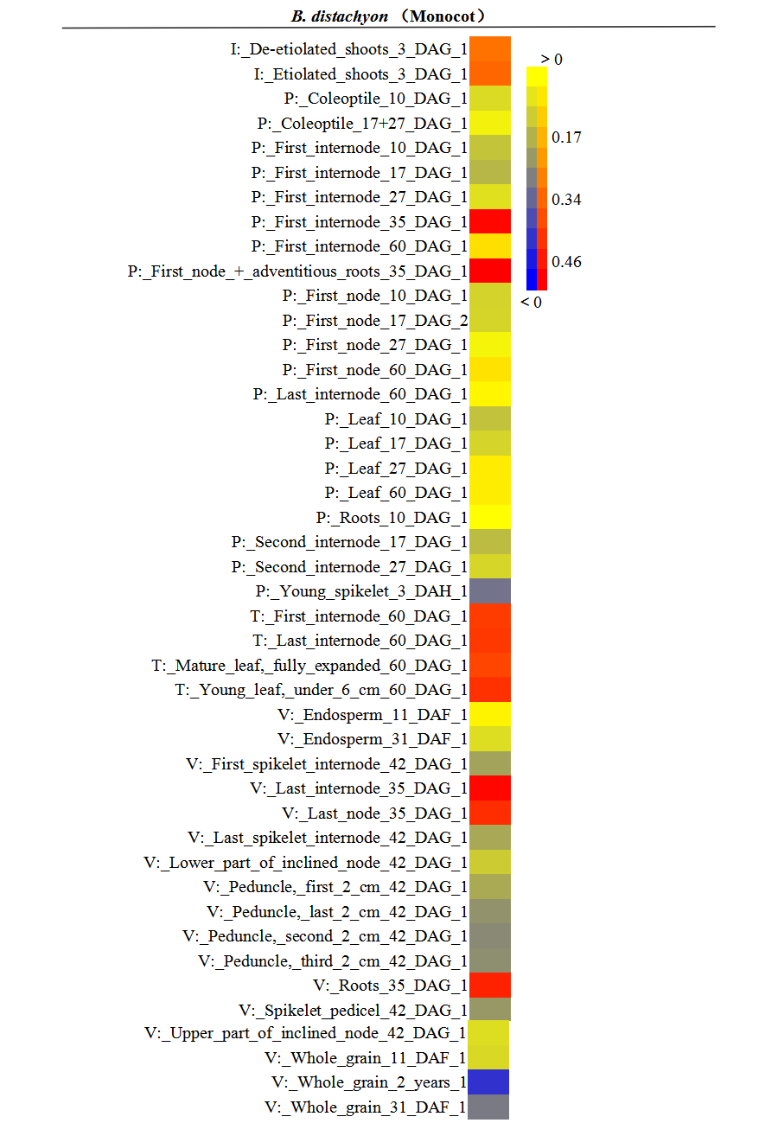
Figure S2 Expression pattern of Brachypodium distachyon (purple false brome) SF1. Expression data were obtained from plant eFP browser microarray datasets and transformed by Log₂ conversion and presented as heatmap. Red colour indicates high levels of transcript abundance and blue indicates low transcript abundance.
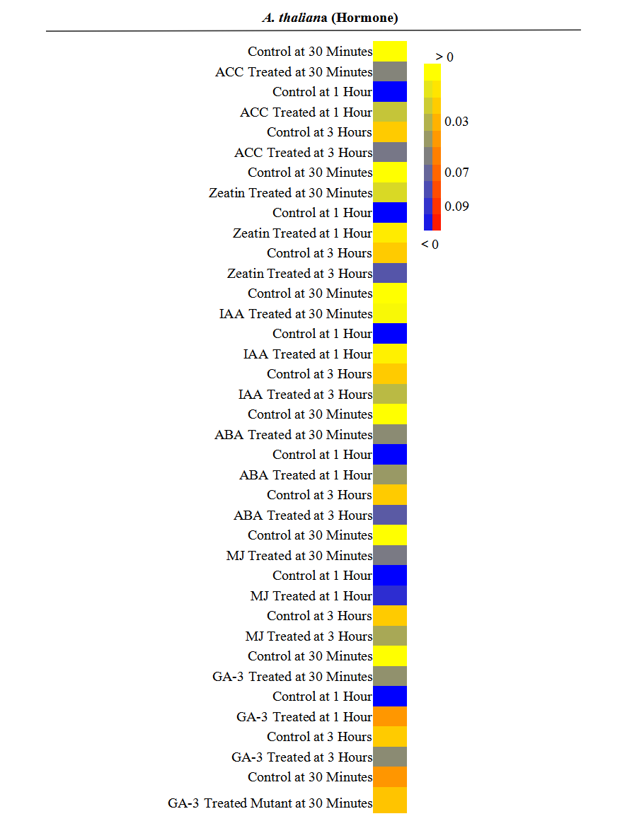Figure S3 The expression of Arabidopsis SF1 gene is affected by multiple phytohormone treatments. Expression data of Arabidopsis were downloaded from plant eFP browser microarray datasets and transformed by Log2 conversion and presented as heatmap. Red colour indicates high levels of transcript abundance and blue indicates low transcript abundance.

